www.lewmasdigital.com
info@lewmasdigital.com
+254-706-600-875

MAY 14, 2020
The Chief Executive Officer
Safaricom ltd
P O BOX 46350-00100 GPO,
NAIROBI
Dear Sir
RE: BULK SMS SERVICE
This is to certify that LEWMAS DIGITAL SOLUTIONS LIMITED has certified Cloud Rebue Solutions to be sending bulk SMS on our behalf with the sender ID: LEWMAS
Please accord them with all the assistance they require.
Thank you.
Yours faithfully
[sign here]
Samwel Mwangi
samwel@lewmasdigital.com
Director
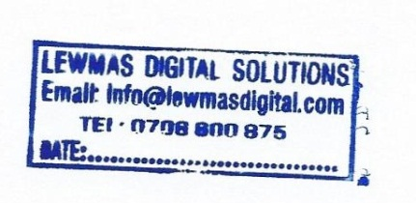
14/05/2020

